ＰＣＢProcessing technology requirements specification

1.Basic process information
Layers | 8 | Plate type | FR4
Finished plate thickness | 1MM | Finished sheet thickness tolerance | ＋／－１０％
ＰＣＢAcceptance Criteria | National Military Standard | Finished Dimensional Tolerance | ＋／－０．１５ｍｍ
Surface treatment | BGA adopts OSP process | Warpage | 0.75%
Solder mask color | blue | Via Process | plug hole
Character color | white | Craft side

- Stackup Information
Finished Thickness(mm):1.0±0.1
AccountThickness(mm):0.97
LAYER STACKING
TOP |  |  | 0.5oz +Plating
 | PP(3313) | 3.91
GND02 |  |  | 0.5oz
 | Core | 5.12
ART03 |  |  | 0.5oz
 | PP(1080*2) | 5.47
GND04 |  |  | 0.5oz
 | Core | 3.94
ART05 |  |  | 0.5oz
 | PP(1080*2) | 5.47
ART06 |  |  | 0.5oz
 | Core | 5.12
GND07 |  |  | 0.5oz
 | PP(3313) | 3.91
BOTTOM |  |  | 0.5oz +Plating

SINGLE IMPEDANCE：
 | layer | width(mil) | impedance(ohm) | ref layer
 | L1/L8 | 6 | 50 | L2/7
 | L3/L6 | 4.8 | 50 | L2/4;L5/7
DIFFERENTIAL IMPEDANCE:
 | layer | width/space(mil) | impedance(ohm) | ref layer
 | L1/L8 | 4.5/9 | 100 | L2/7
 | L3/L6 | 4.5/9 | 100 | L2/4;L5/7
 | L1/L8 | 5\9 | 90 | L2/7
 | L3/L6 | 5\9 | 90 | L2/4;L5/7
The board factory can adjust the line width according to the actual stack to achieve the purpose of controlling the impedance
3. Screenshot of Impedance Control

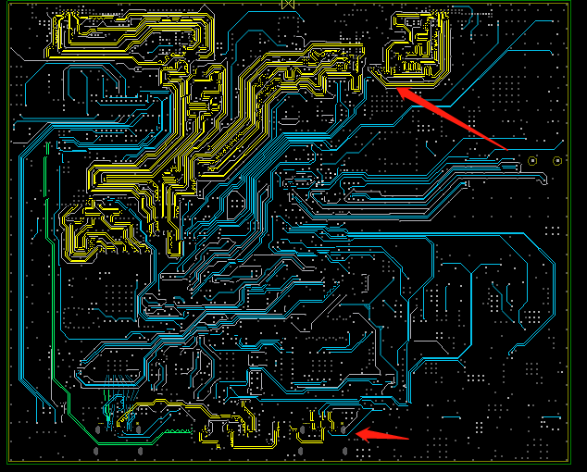
Yellow wire control 100ohm (L3)
Red line width control 90ohm (L3)

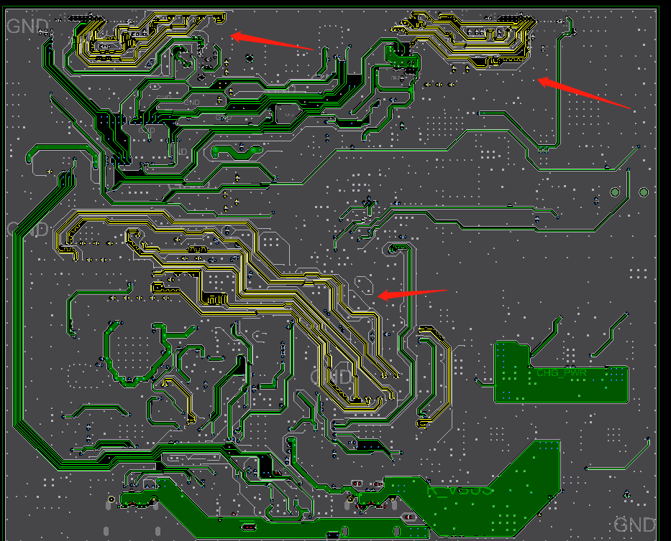
Yellow line width control 100ohm, (L6)

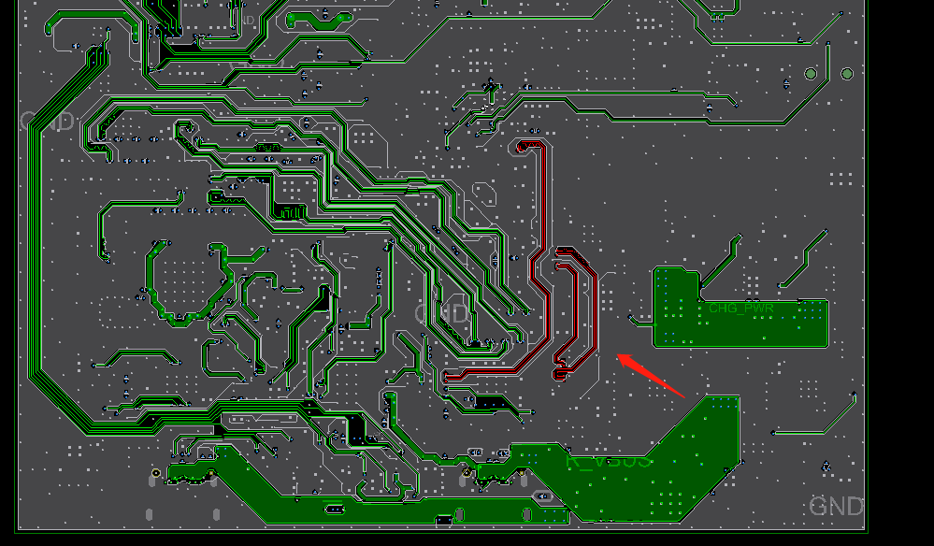
Red line width controlled 90ohm impedance (L6)

